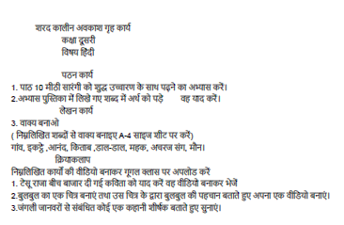







**HOLIDAY HOMEWORK AUTUMN BREAK**

**CLASS -II ENGLISH**

1. **Learn the poem --The Zig Zag boy and Old Mcdonald.**
2. **Make a mask of any animal and learn few lines on that animal to present in class.**
3. **Write 10 similar sounding words in English notebook E.g.see-sea.**
4. **Read and learn any short story related to animals.**
5. **Do reading practice everyday.**
6. **Write and learn 5 sentences on” How to protect yourself from covid-19”.**

**HOLIDAY HOMEWORK**

**CLASS – 2**

**EVS**

**Activity Based –**

**Make Video – (any 2)**

1. Paly a role of any one – our helpers

(like teacher, doctor, pilot etc.)

And speak few sentences.

1. Speak few lines about the importance of means of communication.
2. Dig a hole and sow a seed, capture every new observation and speak few lines about your experience.
3. Wear clothes that suits to your favorite festival and speak few lines.

**CUT And PASTE –**

1. Pictures of indoor and outdoor games.
2. Different means of transport.

**THINK And WRITE – (on A-4 sizes heet only )**

1. What would happen, if we don’t have any means of transport.
2. Why health and hygiene is important for us ?