EVS. CLASS 4. Autumn break home work

1. Talk with a vegetable seller in your area; ask the question given in your T.B page 125 and 126 and make a brief report on A4 sheet.
2. Make a homemade sanitizer
3. Make a model of a birds and it’s nest
4. Grow a vegetable at your home and make a report on it
5. Make a homemade mask

***CLASS 4 MATHEMATICS AUTUMN BREAK HOLIDAY HOMEWORK***

1. Learn tables from 2 to 20.

2. Learn dodging tables from 2 to 20.

3. Practice atleast 20 questions of addition , subtraction, multiplication and division respectively (4-digit no. or greater than 4-digit ). Do in rough copy or A-4 sheet.

4. Make your own fraction kit game play it with your family and post photo .

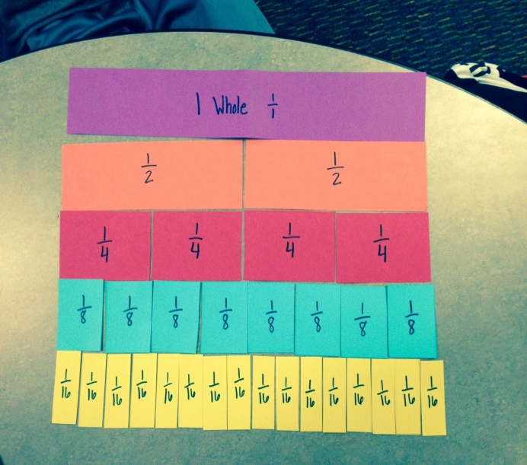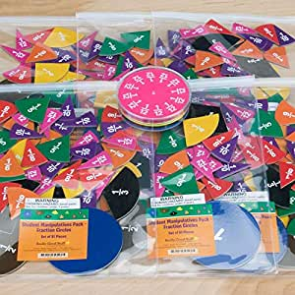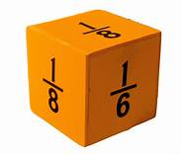

5. Revise all the syllabus of August, September and October month.



