WINTER HOLIDAY HOMEWORK ( ENGLISH)

CLASS 1

WRITE FIVE PAGES OF ENGLISH HANDWRITING.

WRITE TEN LINES ABOUT WINTER SEASON

READ CHAPTER 1 TO 4 OF ENGLISH.

LEARN ALL NEW WORDS OF CHAPTER 1 TO 4.

**WINTER HOLIDAYS HOMEWORK-EVS**

**( 2020-2021)**

**CLASS - I**

**1.Paste pictures of five woollen clothes and write their names.**

**2.Paste pictures of five helpers and write their names.**

**3 Paste pictures of any five festivals of India.**

**4.Collect five flowers and five different leaves and paste it in your scrapbook after drying .**

**5. Make a family tree and paste pictures of your family members.**

**6. Paste pictures of any five activities that helps you to remain healthy.**

WINTER HOLIDAYS HOMEWORK

CLASS - 1

SUBJECT- MATHS

Q1. Write numbers 1-20 and their number names also.

Q2. Circle the objects which you find inside your bag

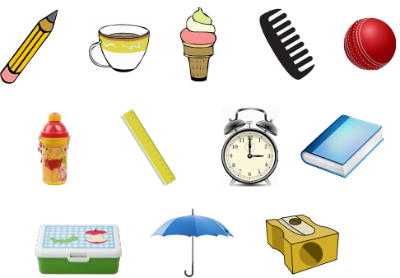

Q3. Color the pictures with the colors given with the numbers:

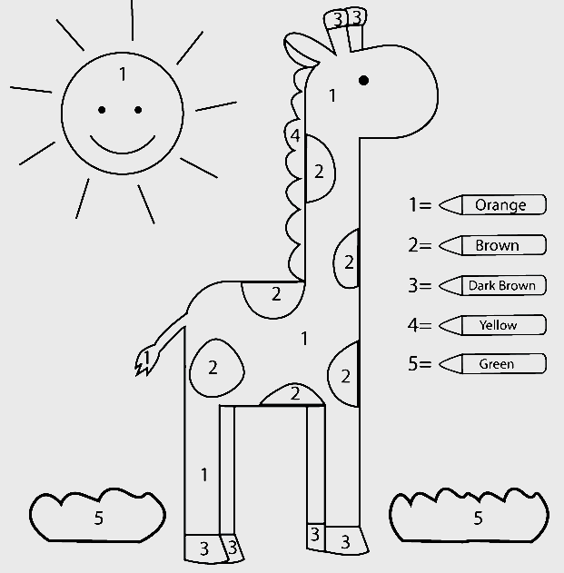

Q4. Match the following shapes:

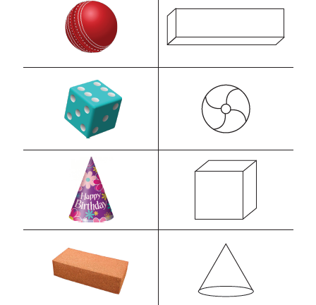

Q5. Add these:

3+4=………….. 6+2=……………… 5+4=……………..

7 3 2

+ 1 + 0 + 2

……… ……. …………

Q6. Subtract these:

8-3=………… 7-5=…………… 9-3=…………….

4 6 5

* 2 - 4 - 3

............ ……….. …………..

**Q7.  I have 6 pencils. Sonu gave me 2 more. How many pencils I have now?**

**Q8. There are 4 students sitting in a row, 3 more are joined to sit in that row.**

**So how many students are in a row now?**

Q9. Kittu has 3 small balls and 2 big balls. How many balls does he have in all?

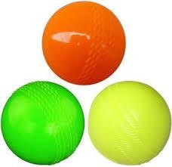 +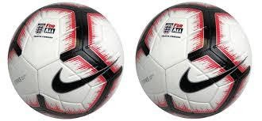

Total balls = __________.

**Q10. Rohan has 5 mangoes . He ate 3 mangoes. How many mangoes are left with her?**

**Q11. There were 7 parrots on a tree, 2 flew away. How many parrots are left on the tree ?**

