***WINTER HOLIDAY HOMEWORK***

***CLASS 4 SUBJECT : MATHEMATICS***

1. LEARN TABLES FROM 2 TO 20.

2. DO 20 QUESTIONS EACH OF ADDITION , SUBTRACTION , MULTIPLICATION AND DIVISION OF ATLEAST 4-DIGIT NUMBER.

3. MAKE A WEIGHING BALANCE AND COMPARE WEIGHTS OF DIFFERENT THINGS AND WRITE YOUR OBSERVATION.

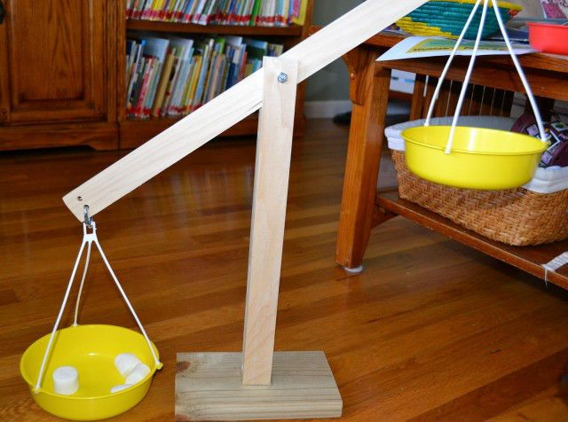

4. PRACTICE CHAPTERS FROM HALVES AND QUARTERS TILL HOW HEAVY ? HOW LIGHT ?

5. RECORD YOUR DAILY EXPERIENCE WHERE YOU ARE USING MATHEMATICS IN DAILY LIFE .

6. COLLECT INFORMATION ABOUT ANY MATHEMATICIAN , WRITE THEIR CONTRIBUTION AND PASTE OR DRAW PICTURE.

7. MAKE ANY PATTERN .

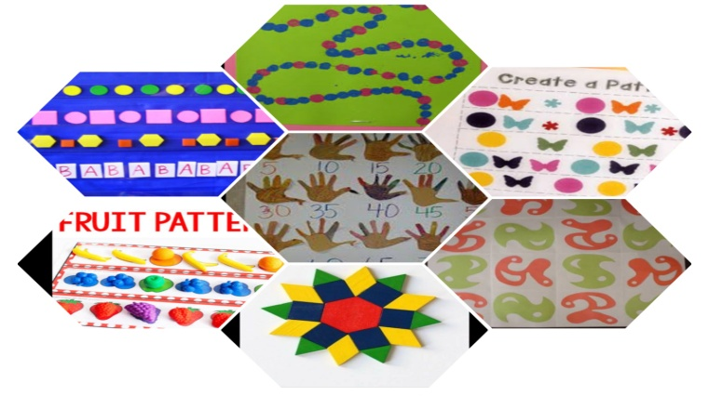

**HOLIDAYS HOME WORK**

**CLASS 4**

**EVS**

1. Take one small pot or ice cream cup, sow some seeds of rajma or grams, 10 to 12 days water it and show different stages on drawing sheet.
2. Paste different types of leaves and name them.
3. Paste or draw pictures of various implements used by a farmer for growing crops.
4. Observe the birds which make nest in your house. Write their names. Also, write the materials which they use for building their nests.
5. Differentiate between Nandita’s village house, Mama’s house and Babloo’s house

|  |  |  |  |  |
| --- | --- | --- | --- | --- |
| S. No |  | Village house | Mama’s house | Babloo’s house |
|  | Number of Rooms |  |  |  |
| 2. | Toilet |  |  |  |
| 3. | Water supply |  |  |  |
| 4. | Electricity |  |  |  |

1. Write the various reasons for the shortage of water?
2. Read and Learn lesson 14 - 19

